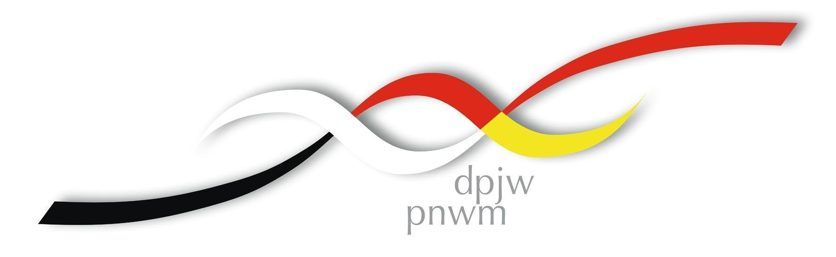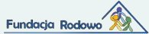

International Youth Education Center Tel. 0048 89 742 81 02
Rodowo 2 Fax. 0048 89 742 84 00
11–731 Sorkwity/ Poland E-Mail: alexander@rodowo.pl

Date:
Registration form:
Hereby I register for the following event:
Event: | German-Polish-Ukrainian Seminar „24 years after Tschernobyl – Does nuclear energy have a future?”
Date of event: | 7th March – 13th March 2009
Participation fee: | none
Surname, Name:
Date of Birth, Place of Birth:
Adress:
Tel./Fax. and E-Mail:
School / University / Profession:
Interests:
Additional Information:
Languages / Diet

Signature:

